## SRI SIDDHARTHA ACADEMY OF HIGHER EDUCATION

*(Declared as Deemed to be University Under Section 3 of the UGC Act, 1956*

Approved by AICTE, Accredited by NBA, NAAC ‘A’ Grade)

**AGALKOTE, TUMKURU-572107 KARNATAKA**

**Mini Project Synopsis on**

**Project Title**

Submitted by

**Chandana R (21IS016)**

**Monika BN (21IS047)**

**In partial fulfillment of**

**BACHELOR OF ENGINEERING**



**DEPARTMENT OF INFORMATION SCIENCE AND ENGINEERING**

**SRI SIDDHARTHA INSTITUTE OF TECHNOLOGY**

*(A Constituent College of Sri Siddhartha Academy of Higher Education)*

MARALUR, TUMKUR-572105

# 2023-24

**ABSTRACT**

The Hostel Management System with Attendance Tracking and Facility Maintenance is a comprehensive database management system designed to streamline and enhance the administrative processes of a hostel. This mini project integrates key features such as attendance tracking, yearly room change details, and maintenance requests for facilities like bulbs, fans, etc.

The system includes a user-friendly interface accessible to both hostel administrators and residents. The attendance tracking module allows administrators to efficiently monitor and manage the attendance of hostel residents. It records daily attendance, tracks patterns, and generates reports, enabling the administration to make informed decisions regarding hostel occupancy.

The yearly room change details module facilitates the easy management of room allocation and changes for residents on a yearly basis. This feature ensures a smooth transition for students changing rooms, and it provides a clear record of room assignments over the years.

Facility maintenance is a crucial aspect of hostel management, and this system incorporates a module for handling maintenance requests. Residents can submit requests for repairs or replacements of items such as bulbs, fans, or any other facilities in their rooms. The system automatically notifies the maintenance staff, tracks the status of each request, and generates reports to assess the overall maintenance performance.

The Hostel Management System aims to improve the overall efficiency of hostel administration by providing a centralized platform for managing attendance, room assignments, and facility maintenance. This mini project contributes to a more organized and responsive hostel management process, ensuring a better living experience for residents.

**Table of Contents**

|  |  |  |
| --- | --- | --- |
| **Sl No** | **Contents** | **Page Number** |
| 1 | Introduction | i |
| 2 | Literature Survey | ii |
|  |  |  |
|  |  |  |
| 3 | System Architecture | iii |
| 4 | Software Requirements | iv |
| 5 | Conclusion | v |
| 6 | References | vii |

**Introduction**

Hostel Management System is a vital component in educational institutions, providing a systematic approach to managing the accommodation and related services for students. This mini project aims to develop an efficient Hostel Management System using HTML, Java, and CSS. The system incorporates key features such as attendance tracking, yearly room change details, and the maintenance of hostel facilities like bulbs, fans, and other amenities.

In today's educational landscape, hostels play a crucial role in shaping the overall experience of students. Managing the various aspects of hostel life requires a well-organized system that can seamlessly handle attendance records, room assignments, and maintenance requests. The integration of HTML for structuring, Java for functionality, and CSS for styling ensures a dynamic and user-friendly interface for both administrators and hostel residents.

**Literature Survey**

1. Hostel Management Systems: A Review

- This paper provides an overview of existing hostel management systems, highlighting their features, functionalities, and technological implementations. It assesses the challenges faced by hostel administrators and the impact of digital systems on improving efficiency.

2. Web-Based Database Management Systems in Educational Institutions

- Investigates the use of web-based database management systems in educational settings, emphasizing the benefits and challenges associated with transitioning from traditional to digital hostel management. The paper explores the role of HTML, Java, and CSS in creating user-friendly interfaces.

3. Attendance Tracking Systems in Educational Environments

- Examines various attendance tracking systems used in educational institutions, discussing the importance of accurate attendance records and the role of technology in streamlining the process. This survey helps identify best practices in attendance management.

4.Dynamic Web Applications for Hostel Room Allocation

- Explores the dynamic allocation of hostel rooms through web applications, focusing on the use of JavaServer Pages (JSP) and HTML for creating responsive interfaces. The paper discusses the challenges and solutions in yearly room change details.

5.Maintenance Management Systems for Residential Facilities

- Investigates the implementation of maintenance management systems for residential facilities, including hostels. It analyzes the role of technology in handling maintenance requests, tracking the status of repairs, and generating performance reports.

6.Database Management in Hostel Administration

- Reviews the role of database management systems in hostel administration, emphasizing the importance of data integrity, security, and efficient query processing. The paper explores how database systems contribute to the overall functionality of hostel management.

7.Challenges and Solutions in Hostel Management Systems

- Identifies common challenges faced by administrators in hostel management and presents solutions proposed in existing literature. This survey helps in understanding the real-world issues that the proposed system aims to adder

**System architecture**

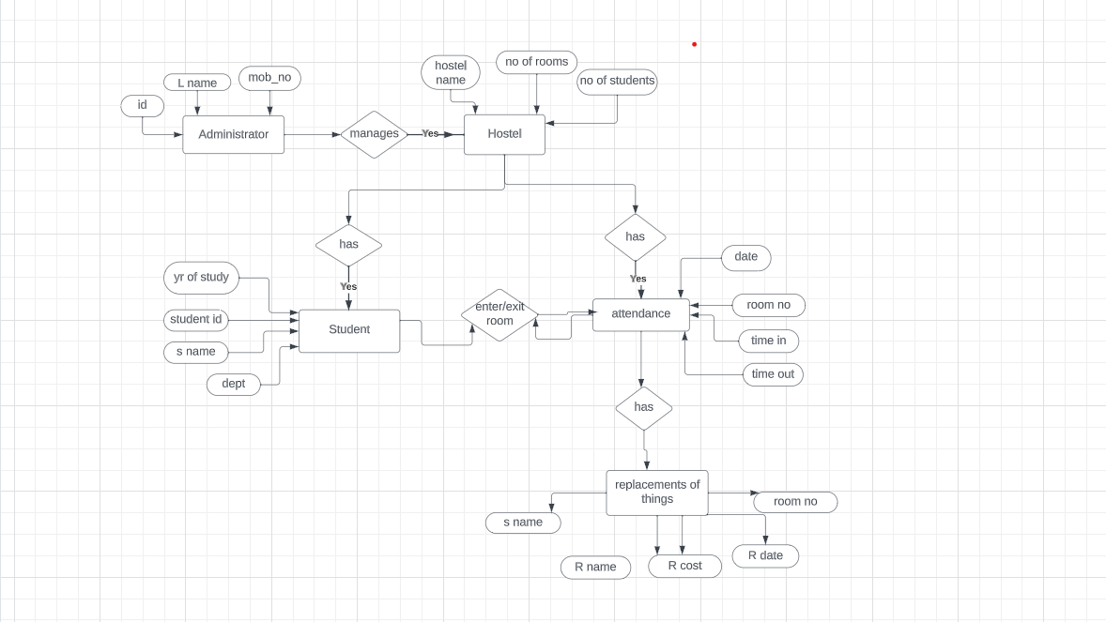

**Software Requirements**

1.Integrated Development Environment (IDE):

2. Java Development Kit (JDK):

3. Database Management System (DBMS):

4. Database Connectivity:

5. Front-end Technologies: HTML, CSS, JavaScript:

6.Version Control: Git

7. Project Documentation:

**Conclusion**

By leveraging the power of these technologies, our Hostel Management System aims to not only streamline administrative tasks but also enhance the overall hostel experience for students. This mini project serves as a practical and hands-on application of database management concepts, web development . It caters to the growing need for advanced and user-friendly systems in educational institutions, ensuring efficient hostel management in the digital age.

**References**

[www.youtube.com](http://www.youtube.com)

**Note:**

Font: Time new roman.

Font Size: Chapter names🡪16

Topics within chapter 🡪14

Subtopics with in topics 🡪12

Contents 🡪12

Figure names and Table names 🡪 12

Margin: Top: 1cm

Bottom: 0.25cm

Inside: 1cm

Outside: 1cm

Borders: Only for Front Sheet, Contents, Abstract.

Line Spacing: 1.5

Paragraph Spacing: 1.5